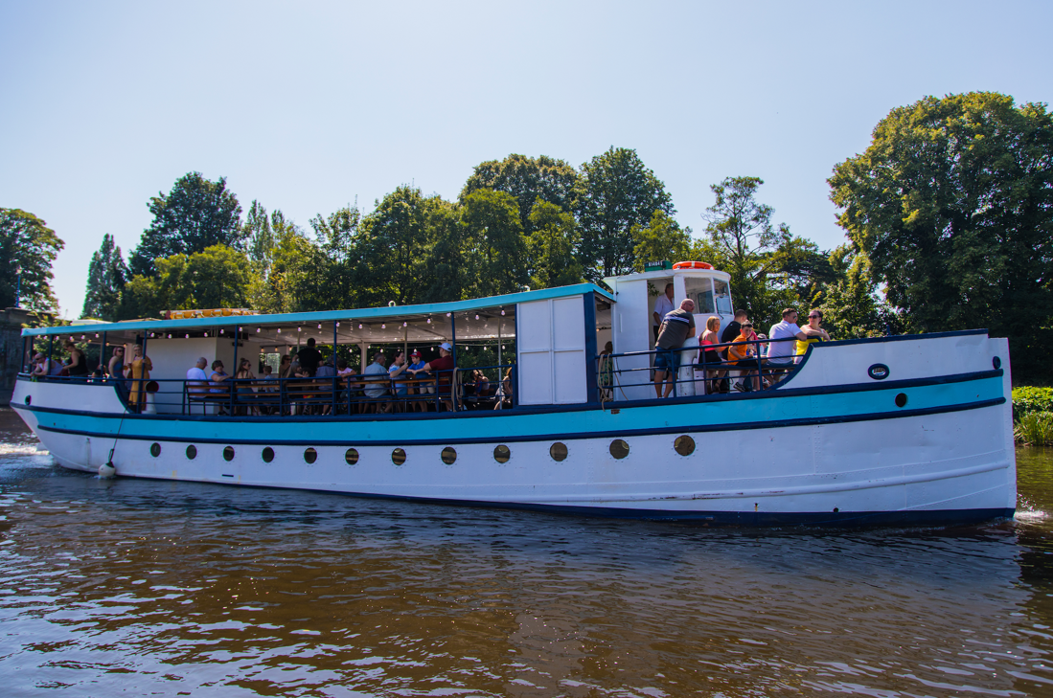

DOMESTIC SAFETY MANAGEMENT SYSTEM

RIVER KING

April 2022

CONTENTS

Page 3 Company Responsibilities & Authority

Page 4 Health & Safety & Environment Protection Policy

Page 5 Disabled Persons Policy & Responsibilities of Master & Training

Page 6 Working Time Directive

Page 7 Procedures for Responding to an Emergency Situation & Mobile Phone Policy

Page 8 Fire Policy

Page 9 Abandon Ship Policy, Violent Act Policy & Assisting other Vessels in an Emergency

Page 10 Pollution Policy & Grounding

Page 11 Man Overboard Policy

Page 12 & 13 Medical Emergency Policy

Collision Policy & Main

Page 14 Propulsion or Steering Failure Policy

Page 15 Procedures for Reporting of Accidents / Incidents

Page 16 Vessel Operating Procedures & Counting & Recording of Passengers Passenger

Page 17 Safety Announcement & Emergency Instruction Broadcast

Page 18 Fuelling, Disposal of Waste & General Navigation Information

Written by Thomas Moore in April 2019

Reviewed & amended in April 2022
Company Responsibilities & Authority

The company is owned by Thomas Moore, trading as Danescroft Leisure.

Thomas Moore is the operator & designated person and can be contacted by telephone on 07810 810161 or by email on hello@riverboathire.co.uk.

The company shall ensure that all persons employed in the operation of the vessel have received appropriate training for the duties that they are required to fulfil and that they understand the relevant rules. The operator shall insure that the policy is implemented, and that responsibilities of all the personnel are understood.

There is a designated link between the ship and the shore base, by mobile phone to ensure that in the event of an emergency there is imminent communication with the emergency services.

The Master’s responsibility shall be laid down so that there is no misunderstanding. He has the authority to make decisions regarding the safety of the ship and persons on board. Assistance shall be available ashore from the company at all times.

Health & Safety & Environmental
Protection Policy.

The objective of the policy is to;
- Ensure safety on board
- Prevent human injury and loss of life
- Comply with the applicable regulations and rules

Safety practices will include:
- A Health & Safety Protection Policy
- Procedures to ensure the safe operation of the RIVER KING in compliance with the relevant rules
- Lines of communication between personnel, ashore and afloat
- Procedures for reporting accidents/incidents and procedures for responding to emergency situations.
It is the policy of the River King to conduct its activities taking full account of the health and safety of their employees and all persons connected with the company, as well as giving proper regards to protecting the environment.
In implementing this policy Thomas Moore will ensure the River King is properly maintained and operated by quality personnel in full compliance with the relevant legislation. In particular Thomas Moore will carry out an assessment of the risks to health and safety of the workers and others affected by the company's operations and will take the necessary measures to minimise the risk‘s identified.
Danescroft Leisure has a responsibility, under the ‘Health and Safety at work act 1974’, to take appropriate action to ensure that the health and safety and well-being of its employees are adhered to at all times. This means reducing the risk of accidents in respect of any employees whose proper performance of their duties is or maybe impaired as a result of drug or alcohol abuse. The consumption or possession of alcohol whilst on duty is not acceptable. Employees should not report to work under the influence of drugs or alcohol.
Passengers under the age of 18 shall not be served alcohol. Passengers under the influence of drugs or alcohol, who may pose danger to themselves or to the crew and passengers, should not be allowed to remain on the vessel. While Danescroft Leisure will take every precaution to prevent human injury or loss of life, we cannot be responsible for any person once they are off the vessel. Danescroft Leisure excepts overall responsibility for all matters relating to safety and environmental protection.

Disabled Persons Policy

Ramped access is available for wheelchairs to the top deck. Assistance should be given to ensure safe access on and off the boat.
Persons in wheelchairs are not allowed below deck.
In the event of an evacuation disabled persons will require further assistance. The Master will need to decide whether to evacuate disabled persons first.

Responsibilities of Master and Training
Masters Authority: Master shall be sole person of authority.

Master must be able to contact Owner/Operator i.e. must have a working mobile phone on their person.

Master must check that a current photo copy of their boat Masters license is on board.
Any medical problems should be reported at once.

Owner/operator will not allow hours of work to exceed working time directive.

Working Time Directive
To protect workers’ health and safety, working hours must meet minimum standards applicable throughout the EU.
The EU’s Working Time Directive (2003/88/EC) requires EU Member States to guarantee the following rights for all workers:
- a limit to weekly working hours
  - the average working time for each seven day period must not exceed 48 hours, including overtime;
  - depending on national legislation and/or collective agreements, the 48 hour average is calculated over a reference period of up to 4, 6 or 12 months
- a rest break during working hours if the worker is on duty for longer than 6 hours
- a minimum daily rest period
  - in every 24 hours a worker is entitled to a minimum of 11 consecutive hours of rest
- a minimum weekly rest period
  - for each 7-day period a worker is entitled to a minimum of 24 uninterrupted hours in addition to the 11 hours' daily rest
- paid annual leave of at least 4 weeks per year
- extra protection in case of night work
  - average working hours must not exceed 8 hours per 24-hour period,
  - night workers must not perform heavy or dangerous work for longer than 8 hours in any 24-hour period,
  - night workers have the right to free health assessments and, under certain circumstances, to transfer to day work.

Procedures for Responding to
an Emergency Situation

Potential emergency situations are identified and exercises carried out to respond to these emergencies. Where appropriate these exercises show involved the personal assure. The exercises shall be recorded. Procedures for responding to emergency situations and reporting incidents – this should include the following:

- Mobile phone alert
- Fire
- Abandon ship
- Violent Act.
- Assisting other vessels in an emergency
- Pollution
- Grounding
- Man overboard
- Medical emergency
- Collision
- Main propulsion or steering failure

Mobile Phone Alert Policy

Ensure there is a charged mobile phone on board before departure.

Fire Policy

Once discovering a fire, identify positions and immediately raise the alarm.

Shut-off all engines and ventilation systems where necessary.

Recover and evacuate anyone injured.

Locate the fire and evaluate the extent of the fire.

Cut off air supplies to fire - close items such as hatches ports doors ventilators and shut off ventilation system.

If safe immediate use portable FOAM fire extinguisher at the base of frames, for flammable liquids or grease fires.

Use the WATER fire extinguisher for fires in ordinary combustible material.

Do not use water on electrical fires use only CO2.

If fire is in machinery spaces, shut off fuel supply and ventilation and manoeuvre vessel to minimise effect of wind on fire.

If unable to control fire, immediately notify the emergency services by mobile phone.

Move passages away from the fire and if necessary, prepare to abandon the vessel.

Abandon Ship Policy

Order crew and passengers with crew assistance, to muster on the top deck.
Contact designated person to inform them of the emergency situation.
Prepare to launch life-rafts.
Ensure life-raft painter is attached a vessel, launch life-raft.
Embark all passengers onto the life-raft.
Embark all crew onto the life-rant.
Cut Painter
Check for persons in the water
Administer first aid as required
Maintain a lookout for vessels coming to assistance
Remain in safe proximity to the ship and in contact with the emergency services.

Violent Act Policy

Protect safety of the other passengers and crew by isolating perpetrator(s).
Request assistance from shore by mobile phone.
Divert to nearest point where assistance will be available.
Attempted a defuse situation without resulting to force.

Assisting other Vessels in an Emergency

Consider the risks to your passengers as a priority.

Pollution Policy

Stop pollution by any available means - i.e. stop bilge pump, plugs scuppers, order passengers to stop throwing garbage over side etc.
Report position, type of pollutant, amount of pollutant and other relevant information to environment agency.
Clean any oil spill on board.
Retain cleaning equipment/residue.
Inform Owner/Operator

Grounding Policy

Stop engines, exhibit navigation lights and make appropriate sound signals.
Switch on deck lighting.
Check the hull for damage.
Sound bilges and tanks.
Visually inspect compartments where possible.
Sound around ship.
Determined where deep water lies.
Determine nature of riverbed.
Reduce draught of ship if possible.
Inform Owner/Operator

Man Overboard Policy

Raise the alarm by shouting ‘MAN OVERBOARD!’ to alert all on board.
Disengage propellers.
Post lookout to maintain continuous watch on man overboard.
Release lifebuoy with light on rope as appropriate on the side the person has fallen overboard.
Take immediate avoiding action so as not to run over the man overboard.
Commence a recovery manoeuvre.
Prepare recovery equipment. Hamley lifeline, Davit and pulley gear, stored in top deck store cupboard. Emergency ladder on roof.
Lifeline is used to support person under shoulders. Davit and pulley gear is used to bring person back on board.
Once recovered administer first-aid qualified.

Medical Emergency Policy

Contact 999 immediately.
Road access for emergency vehicles:
- Stourport Bridge – DY13 8XA (Postcode)
– asset.option.regime (what3words)
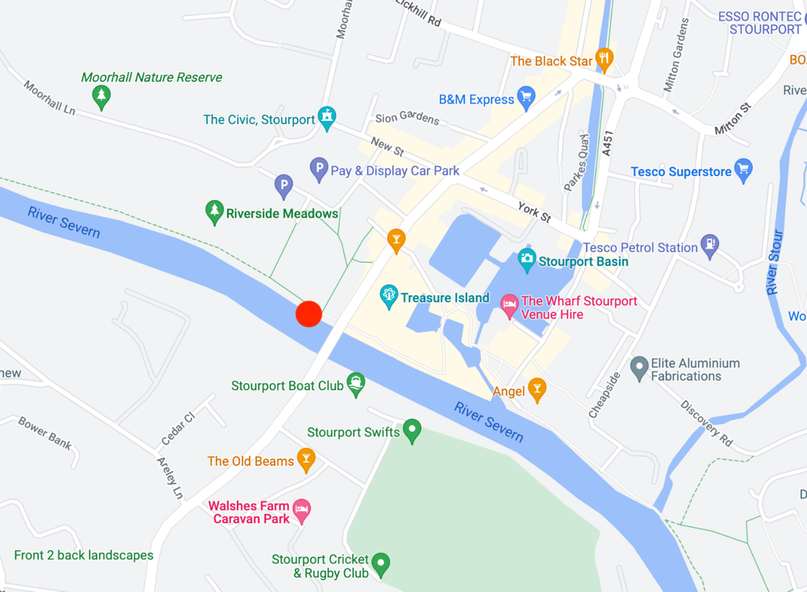

- Lincombe Lock – DY13 9QB
– oppose.crypt.reclusive (what3words)
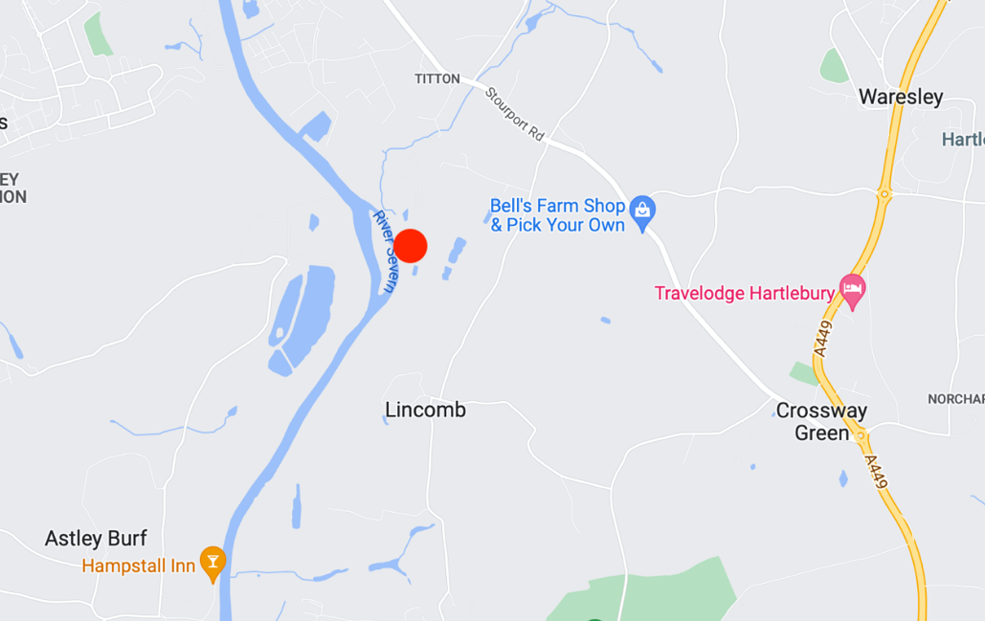

- Hampstall Inn – DY13 0PY
– drives.originals.dizziness (what3words)

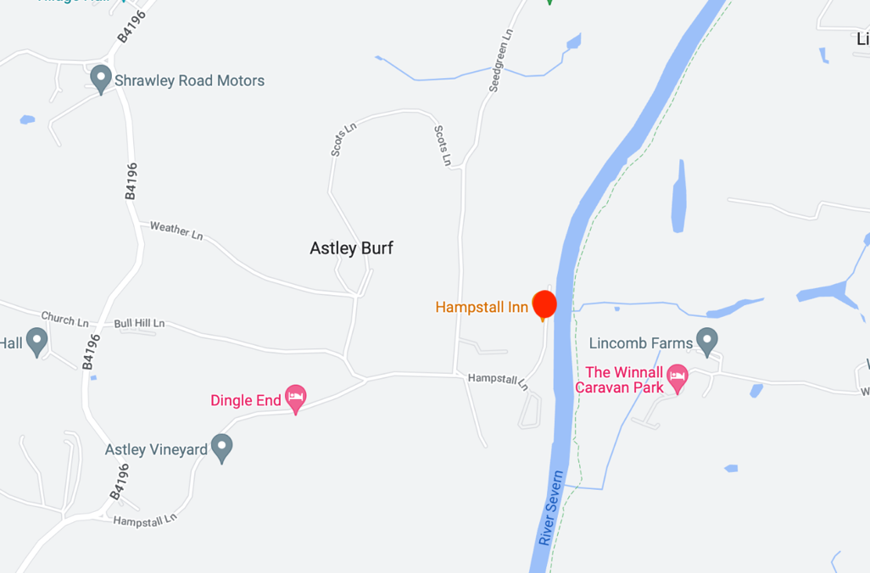

- Lenchford Inn – WR6 6TB
– sympathy.tram.snippet (what3words)

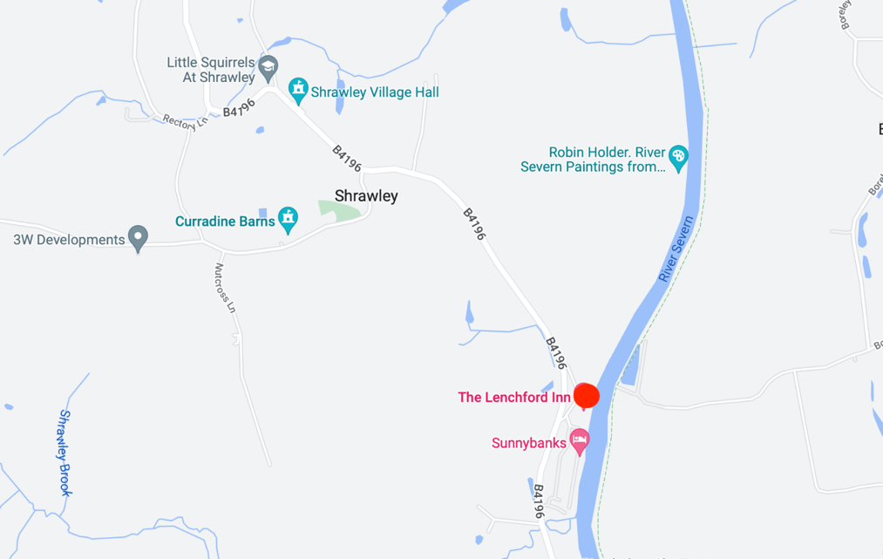

Collision Policy

Manoeuvre the vessel so as to minimise effect of collision
Switch on deck lighting at night
Check for hull damage

Main Propulsion or Steering Failure Policy

Prepare for anchoring
Engage emergency steering
Manoeuvre vessel away from nearest danger

Reporting of Accidents

The requirements for reporting accidents should be well understood for all personnel and in doing so improve the safety culture practiced on board.
All accidents are near accident shall be recorded and reported to the operator, who shall implement corrective action, with the aim of improving safety.
It is essential that in the event of an emergency, the master or crew members communicate with the emergency services via mobile phone. Depending on the level of emergency, contact will be made to either the operator/owner and Police, Ambulance or Fire Service.
An accident logbook is to be kept on board the vessel. Date, time, incident, person involved, action taken and witnesses to be locked at all times in the accident logbook.
The Master shall inform the Marine Accident Investigation Branch (MAIB) of all accidents in accordance with The Merchant Shipping (Accident Reporting and Investigation) Regulations 1999. The MCA should also be informed, if the accident is such that the validity of the ship’s Passenger Certificate or Domestic Safety Management Certificate may be affected.
Incident reporting processes.
All incidents / accidents should be reported immediately to the Owner/Operator for them to contact the insurance company. In all cases please obtain names and addresses of any witnesses and if at all possible, obtain a signed statement from them at the time of the incident. In the case of damage to the vessel, no repairs may commence before the vessel has been surveyed unless they are of an emergency nature or below the policy excess.

Vessel operating procedures /
Onboard procedures
There are procedures in place for key shipboard operations with regards to safety. The tasks involved in these procedures are assigned to the Owner/Operator.
Safe boarding of passengers.
Passengers will board the vessel from appropriate point on the riverfront.
Passengers will board using ramps/steps on the Starboard side of the vessel and crew will assist all passengers when embarking and disembarking. Emergency exit, life-raft and perrybouys MUST be unlocked before departure.
Test steering before departure.

Counting & Recording of Passengers

Owner / Operator is responsible for the upkeep of this information in accordance with the requirements of the regulations.
Method of accounting/registering of passengers are conducted through a “Clicker system” -
The master or a member of crew shall count each passenger boarding using a consecutively numbering (hand-held) counting device and note the number. Any persons disembarking shall be similarly counted and recorded using the clicker. The Master or a member of crew shall, before departure, record the information. The system shall be applied to all persons boarding and disembarking from the vessel for a voyage. The system shall account for all persons on board the vessel at all times. Each person on board the vessel must have the relevant details recorded irrespective of whether they are a feepaying passenger or not.
Method of deposition of information is sure is conducted by message via phone. The information is updated at each landing/stopping point where persons may embark or disembark the vessel. The system shall ensure that information concerning passengers who have declared a need for special assistance or care in an emergency situation is properly recorded and that the Master is informed prior to departure. The master shall ensure that the vessel does not depart if the number of persons on board exceeds the total number of the vessel is certified to carry.

Passenger Safety Announcement

Passengers shall be given emergency information at the commencement of each voyage. A public address system will be used to inform passengers of the action they should take in the event of an emergency which could lead to the ship being abandoned. Information provided includes:
The methods to be used to inform passengers of an emergency has occurred, either public address system or by the person in charge.
The action they will required to take in the event of an emergency
Type of life-saving appliances on board
How to use the life-saving appliances
Announcements are made in a clear and simple manner. They are brief but compatible with the need to convey sufficient information to assist all concerned in the event of an emergency landing to abandonment. The announcement is prefaced by a request for everyone’s attention. No other announcement or music is allowed to be broadcast while the passenger emergency instructions announcement is made.

Emergency Instruction Broadcast.

Ladies and gentlemen please listen to the following safety announcement. In the unlikely event of an emergency you will be informed by a means of an announcement or by a member of crew. Please remain calm at all times. The vessel is equipped with life boys and life-rafts which can be manually launched in the event of an emergency. If evacuation is required, you will be instructed by the master or crew member to proceed to the nearest accessible exit and to enter the water. When in the water take hold of one of the grab lines on the lifebuoy or buoyancy apparatus. Each lifebuoy we can support two persons, the inflatable life-raft can support 65 persons, the smaller buoyancy apparatus can support 10 persons and the larger ones 20 persons.

Fuelling
Vessel to be checked and filled if necessary by owner/operator before any departure.
No fuelling will take place whilst passages are on board the vessel.

Disposal of Waste
Litter bins are provided on the vessel passengers are reminded of the litter disposal in the safety announcement disposal of daily land garbage and oil rich you wish you did such it is by owner/operator

General Navigation Information
Weather conditions-master to check local weather forecast the previous night and morning prayer prior to sailing if weather conditions are variable always Aeron the side of caution. Poor light – fog, high wins – severe weather forecast could warrant cancellation.

The company has developed procedures in the form of checklist to assist in the safety management of our River King see daily weekly monthly checklist attached.

